Field Service System
What problem Solve?

Customer → Owner/Manager → Technician

Role | Main responsibility
Customer | Creates and tracks service requests
Owner | Full control of the business
Manager | Manages requests, technicians, schedules
Technician | Accepts and completes assigned jobs

Only 5 Important Module for this

Module | What it contains
Customer & Asset | Profiles, addresses, appliances/assets, history
Service Request & Jobs | Request creation, status workflow, attachments
Technician & Scheduling | Skills, assignment, accept/reject, schedule, leave
Inventory & Parts | Stock, job parts, stock transactions
Billing & Warranty | Invoice, payment, warranty, PDF

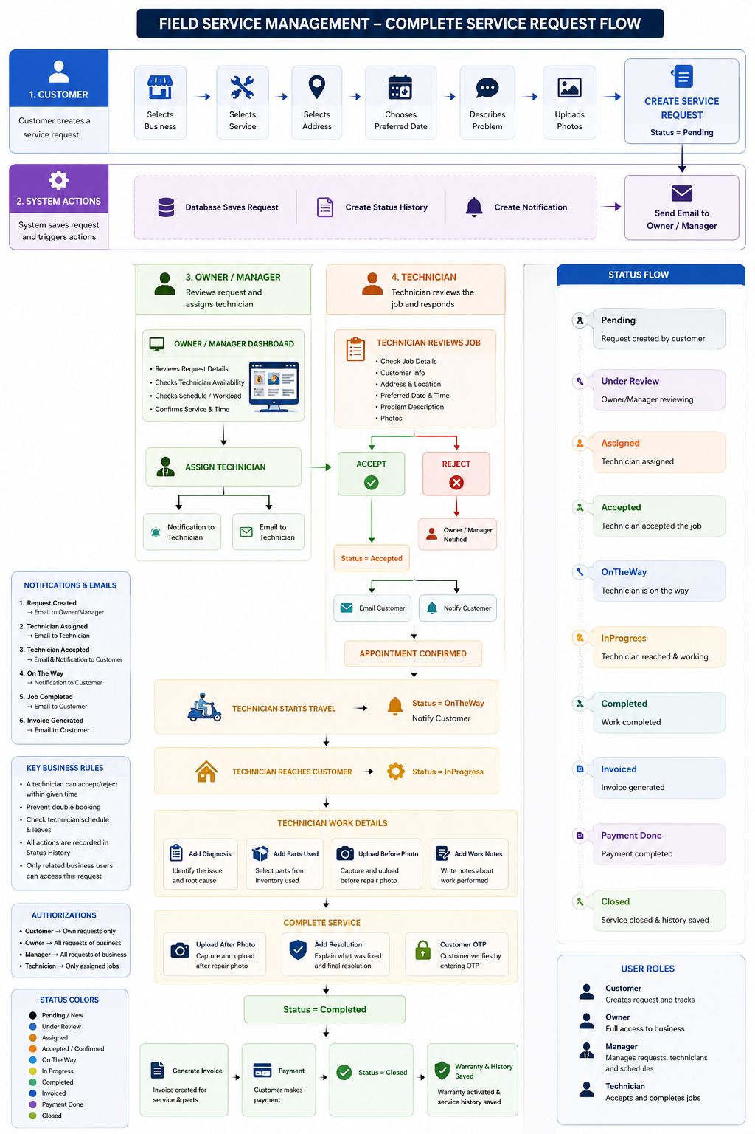
Databse

1.User
Id | UUID | PK
FirstName | VARCHAR(100)
LastName | VARCHAR(100)
Email | VARCHAR(255) | UNIQUE
PhoneNumber | VARCHAR(20)
PasswordHash | TEXT
UserType | VARCHAR(20) | Customer / BusinessUser
IsEmailVerified | BOOLEAN
IsActive | BOOLEAN
CreatedAt | TIMESTAMPTZ
UpdatedAt | TIMESTAMPTZ

2.

Businesses
Stores service businesses.
Id | UUID | PK
Name | VARCHAR(200)
Slug | VARCHAR(150) | UNIQUE
Email | VARCHAR(255)
PhoneNumber | VARCHAR(20)
LogoUrl | TEXT
AddressLine | VARCHAR(255)
City | VARCHAR(100)
State | VARCHAR(100)
Country | VARCHAR(100)
PostalCode | VARCHAR(20)
TimeZone | VARCHAR(100)
CurrencyCode | VARCHAR(3)
IsActive | BOOLEAN
CreatedAt | TIMESTAMPTZ
UpdatedAt | TIMESTAMPTZ

3.

BusinessMembers
Connects Owner, Manager and Technician to a business.
Field | Type | Key
Id | UUID | PK
BusinessId | UUID | FK → Businesses.Id
UserId | UUID | FK → Users.Id
Role | VARCHAR(20) | Owner / Manager / Technician
EmployeeCode | VARCHAR(50)
IsActive | BOOLEAN
JoinedAt | TIMESTAMPTZ

Businesses
└── BusinessMembers
|
Users

4.

CustomerAddresses
A customer can save multiple service addresses.

Field | PostgreSQL Type | Key / Constraint | Description
Id | UUID | PK | Address identifier
CustomerId | UUID | FK → Users.Id, NN | Customer
Label | VARCHAR(50) | NN | Home, Office, Shop
AddressLine1 | VARCHAR(255) | NN | Main address
AddressLine2 | VARCHAR(255) | NULL | Additional address
Landmark | VARCHAR(255) | NULL | Nearby landmark
City | VARCHAR(100) | NN | City
State | VARCHAR(100) | NN | State
Country | VARCHAR(100) | NN | Country
PostalCode | VARCHAR(20) | NN | Postal code
IsDefault | BOOLEAN | NN | Default address
CreatedAt | TIMESTAMPTZ | NN | Created time
UpdatedAt | TIMESTAMPTZ | NULL | Updated time

5.

CustomerAssets
Stores customer devices/equipment.
Id | UUID | PK | Asset identifier
CustomerId | UUID | FK → Users.Id, NN | Asset owner
AssetType | VARCHAR(100) | NN | AC, TV, CCTV
Name | VARCHAR(150) | NN | Friendly asset name
Brand | VARCHAR(100) | NULL | Brand
Model | VARCHAR(100) | NULL | Model
SerialNumber | VARCHAR(150) | NULL | Serial number
PurchaseDate | DATE | NULL | Purchase date
Notes | TEXT | NULL | Extra information
IsActive | BOOLEAN | NN | Active status
CreatedAt | TIMESTAMPTZ | NN | Created time
UpdatedAt | TIMESTAMPTZ | NULL | Updated time

6.

ServiceCategories
Groups services offered by a business.
Field | PostgreSQL Type | Key / Constraint | Description
Id | UUID | PK | Category identifier
BusinessId | UUID | FK → Businesses.Id, NN | Business
Name | VARCHAR(150) | NN | Category name
Description | TEXT | NULL | Description
IsActive | BOOLEAN | NN | Active status
CreatedAt | TIMESTAMPTZ | NN | Created time
UpdatedAt | TIMESTAMPTZ | NULL | Updated time

7.

Services
Stores actual services.
Field | PostgreSQL Type | Key / Constraint | Description
Id | UUID | PK | Service identifier
BusinessId | UUID | FK → Businesses.Id, NN | Business
CategoryId | UUID | FK → ServiceCategories.Id, NN | Category
Name | VARCHAR(200) | NN | Service name
Description | TEXT | NULL | Description
BasePrice | NUMERIC(12,2) | NN | Starting price
EstimatedMinutes | INTEGER | NN | Expected duration
IsActive | BOOLEAN | NN | Active status
CreatedAt | TIMESTAMPTZ | NN | Created time
UpdatedAt | TIMESTAMPTZ | NULL | Updated time

8.

ServiceRequests
Field | PostgreSQL Type | Key / Constraint | Description
Id | UUID | PK | Request identifier
RequestNumber | VARCHAR(50) | UQ, NN | Human-readable number
BusinessId | UUID | FK → Businesses.Id, NN | Selected business
CustomerId | UUID | FK → Users.Id, NN | Request creator
ServiceId | UUID | FK → Services.Id, NN | Selected service
AssetId | UUID | FK → CustomerAssets.Id, NULL | Device being serviced
AddressId | UUID | FK → CustomerAddresses.Id, NN | Service location
Title | VARCHAR(200) | NN | Problem title
Description | TEXT | NN | Problem description
Priority | VARCHAR(20) | NN | Low, Normal, High, Urgent
Status | VARCHAR(30) | NN | Current workflow status
PreferredDate | DATE | NULL | Customer preferred date
PreferredTimeWindow | VARCHAR(30) | NULL | Morning, Afternoon, Evening
ScheduledStartAt | TIMESTAMPTZ | NULL | Confirmed start
ScheduledEndAt | TIMESTAMPTZ | NULL | Confirmed end
CancellationReason | TEXT | NULL | Reason for cancellation
CreatedAt | TIMESTAMPTZ | NN | Request creation
UpdatedAt | TIMESTAMPTZ | NULL | Last update
CompletedAt | TIMESTAMPTZ | NULL | Completion time
ClosedAt | TIMESTAMPTZ | NULL | Closing time
CancelledAt | TIMESTAMPTZ | NULL | Cancellation time

9.

RequestAttachments
Stores customer and technician uploads.
Field | PostgreSQL Type | Key / Constraint | Description
Id | UUID | PK | Attachment identifier
ServiceRequestId | UUID | FK → ServiceRequests.Id, NN | Related request
UploadedByUserId | UUID | FK → Users.Id, NN | Uploader
AttachmentType | VARCHAR(30) | NN | ProblemPhoto, BeforePhoto, AfterPhoto, Document
FileName | VARCHAR(255) | NN | Original file name
FileUrl | TEXT | NN | Stored file URL
CreatedAt | TIMESTAMPTZ | NN | Upload time

10.

TechnicianSchedules
Stores technician weekly availability.
Field | PostgreSQL Type | Key / Constraint | Description
Id | UUID | PK | Schedule identifier
TechnicianMemberId | UUID | FK → BusinessMembers.Id, NN | Technician
DayOfWeek | SMALLINT | NN | 0–6
StartTime | TIME | NN | Work start
EndTime | TIME | NN | Work end
IsWorkingDay | BOOLEAN | NN | Working or off

11.

JobAssignments
Stores technician assignment history.
Field | PostgreSQL Type | Key / Constraint | Description
Id | UUID | PK | Assignment identifier
ServiceRequestId | UUID | FK → ServiceRequests.Id, NN | Request
TechnicianMemberId | UUID | FK → BusinessMembers.Id, NN | Assigned technician
AssignedByMemberId | UUID | FK → BusinessMembers.Id, NN | Owner/Manager
Status | VARCHAR(30) | NN | Pending, Accepted, Rejected, Cancelled
AssignedAt | TIMESTAMPTZ | NN | Assignment time
AcceptedAt | TIMESTAMPTZ | NULL | Acceptance time
RejectedAt | TIMESTAMPTZ | NULL | Rejection time
RejectionReason | TEXT | NULL | Why rejected

12.

JobStatusHistory
Stores the full request timeline
Field | PostgreSQL Type | Key / Constraint | Description
Id | UUID | PK | History identifier
ServiceRequestId | UUID | FK → ServiceRequests.Id, NN | Request
FromStatus | VARCHAR(30) | NULL | Previous status
ToStatus | VARCHAR(30) | NN | New status
ChangedByUserId | UUID | FK → Users.Id, NN | Who changed it
Note | TEXT | NULL | Optional note
ChangedAt | TIMESTAMPTZ | NN | Change time

13.

JobWorkDetails
Stores diagnosis and actual work.
Field | PostgreSQL Type | Key / Constraint | Description
Id | UUID | PK | Work identifier
ServiceRequestId | UUID | UQ, FK → ServiceRequests.Id, NN | One work record/request
TechnicianMemberId | UUID | FK → BusinessMembers.Id, NN | Technician
Diagnosis | TEXT | NULL | Found problem
WorkPerformed | TEXT | NULL | Work done
Resolution | TEXT | NULL | Final solution
StartedAt | TIMESTAMPTZ | NULL | Work start
FinishedAt | TIMESTAMPTZ | NULL | Work finish
CompletionOtp | VARCHAR(10) | NULL | Simple V1 OTP
OtpVerified | BOOLEAN | NN | OTP verification
CreatedAt | TIMESTAMPTZ | NN | Created time
UpdatedAt | TIMESTAMPTZ | NULL | Updated time

14.

InventoryItems
Stores spare parts.
Field | PostgreSQL Type | Key / Constraint | Description
Id | UUID | PK | Item identifier
BusinessId | UUID | FK → Businesses.Id, NN | Business owner
SKU | VARCHAR(100) | NN | Stock code
Name | VARCHAR(200) | NN | Item name
Description | TEXT | NULL | Description
Quantity | NUMERIC(12,3) | NN | Current stock
CostPrice | NUMERIC(12,2) | NN | Purchase cost
SellingPrice | NUMERIC(12,2) | NN | Customer price
IsActive | BOOLEAN | NN | Active status
CreatedAt | TIMESTAMPTZ | NN | Created time
UpdatedAt | TIMESTAMPTZ | NULL | Updated time

15.

JobParts
Stores parts consumed in a job.
Field | PostgreSQL Type | Key / Constraint | Description
Id | UUID | PK | Usage identifier
ServiceRequestId | UUID | FK → ServiceRequests.Id, NN | Job
InventoryItemId | UUID | FK → InventoryItems.Id, NN | Part
TechnicianMemberId | UUID | FK → BusinessMembers.Id, NN | Technician
Quantity | NUMERIC(12,3) | NN | Quantity used
UnitPrice | NUMERIC(12,2) | NN | Price at time of usage
AddedAt | TIMESTAMPTZ | NN | Added time

16.

Invoices
Stores final billing, payment, and simple warranty details.
Field | PostgreSQL Type | Key / Constraint | Description
Id | UUID | PK | Invoice identifier
InvoiceNumber | VARCHAR(50) | UQ, NN | Invoice number
ServiceRequestId | UUID | UQ, FK → ServiceRequests.Id, NN | One invoice/request
BusinessId | UUID | FK → Businesses.Id, NN | Business
CustomerId | UUID | FK → Users.Id, NN | Customer
ServiceAmount | NUMERIC(12,2) | NN | Service charge
PartsAmount | NUMERIC(12,2) | NN | Parts total
DiscountAmount | NUMERIC(12,2) | NN | Discount
TaxAmount | NUMERIC(12,2) | NN | Tax
TotalAmount | NUMERIC(12,2) | NN | Final total
PaymentStatus | VARCHAR(20) | NN | Unpaid, Paid
PaymentMethod | VARCHAR(30) | NULL | Cash, UPI, Card, BankTransfer
TransactionReference | VARCHAR(255) | NULL | Payment reference
IssuedAt | TIMESTAMPTZ | NN | Invoice time
PaidAt | TIMESTAMPTZ | NULL | Payment time
WarrantyStartDate | DATE | NULL | Warranty start
WarrantyEndDate | DATE | NULL | Warranty end
WarrantyTerms | TEXT | NULL | Warranty terms
CreatedAt | TIMESTAMPTZ | NN | Created time
UpdatedAt | TIMESTAMPTZ | NULL | Updated time

